



MEBS System
Getting started manual.
March 27th, 2013
Document Id: MEBS System
Version number: 1.0

STRICTLY CONFIDENTIAL
This document of Motive Television is for restricted circulation. No part of this publication may be reproduced, stored in a retrieval system, or transmitted in any form or by any means – recording, photocopying, electronics and mechanical without prior written permission of Motive Television.

Copyright ©2006-2013
MOTIVE TELEVISION All rights reserved.

Barcelona, Catalonia, Spain
Tel: +34 93 184 29 81 Fax: +34 678 994 539
www.motivetelevision.co.uk

First release: March 27th, 2013
Document Id: MEBS System

Security Policy of Motive Television
Any recipient of this document, without exception, is subject to a Non-Disclosure Agreement (NDA).

- Only controlled hardcopies of the document shall have signatures on them.
- This is a restricted document. Unauthorized access or copying is prohibited.
- Uncontrolled when printed unless signed by approving authority.
- Should this document come into your possession and you are not the intended recipient: Motive Television kindly requests and thanks you in advance for making contact at your earliest convenience for instructions on how to proceed with its disposal.
Document control sheet

Ver. No. | Release Date | Description of Change | Authored/Revised By | Reviewed By
1.0 | 27-03-2013 | Initial draft. | Karima Goubar

Contents
1 Introduction : 6
2 Menu: 7
3 Automatic-recording Management: 8
3.1 Search 8
3.2 View EPG Details 10
3.3 Prepare Custom User EPG collection to be Recorded 10
3.3.1 Add EPG event(s) to User Collection 10
3.3.2 Remove EPG event(s) from User Collection 13
3.4 Edit EPG Event 14
3.5 Publish EPG Event 18
3.6 Manage Publish EPG Event 18
3.6.1 Edit EPG event 20
3.6.2 Depublish EPG event 20
3.6.3 Extends EPG event life 20
4 Datacasting Management: 22
4.1 Search 22
4.2 Edit VOD content 23
4.3 Publish VOD content 27
4.4 Manage published VOD content 31
4.4.1 Edit VOD content 31
4.4.2 Depublish VOD content 31
4.4.3 Extends VOD content life 31
5 Broadcasting Manual Recommendations: 33
5.1 Search 33
5.1.1 AR Events / Live Events 34
5.1.2 VOD Events 37
5.2 Create Custom Recommendation EPG events collection 38
6 Broadcasting Banners: 40
7 Broadcasting Channels Logo 40
8 Broadcasting Search Index File: 42
9 DigiTurk Site Guide 43
9.1 Production Environment Setup 43
9.2 Certification Environment Setup 44
10 Brief Components Description 45
11 How to Configure Channels 46
11.1 Lysis output channels : 46
11.2 Add new channel : 47
11.3 Edit / Remove Channel 47
12 How To Configure DVB-Triplet: 48
12.1 Search List Channel DVB-Triplet : 48
12.2 Add new DVB-Triplet : 48
12.3 Edit / Remove DVB-Triplet(s) 49
13 How To Configure System Service Importer 49
14 How to configure Catalog : 51
14.1 List of Categories: 51
14.2 Add new Category : 52
14.3 Edit/Remove Category: 52
15 EBS Parameters. 53
15.1 Global Settings (Easy Configuration): 53
15.2 All Settings: 55

Introduction :
Motive MEBS HeadEnd Media Asset Manager (MEBSMAM) is the EPG/VOD management system of data coming from JADE & Digiturk Xport system. Within the MEBSMAM is it possible to:

- JADE entries management (automatic recording).
- Xport VOD entries management (Datacasting).
- Advertising

In order to access MEBSMAM by Motive (data access web application) customer will receive an e-mail from Motive’s team with the following data:

- URL: application internet address.
- Login: username necessary to access web application.
- Password: password for this username.

Example: For CME (Figure 1.1)

http://10.43.60.15/MEBSMAM/Login.aspx (Production Main Web Server)
http://172.28.28.31/EBSMAM/Login.aspx (Production Slave Web Server)
http://172.28.28.11/EBSMAM/Login.aspx (Lab Web Server)

User Name: user

Password: user

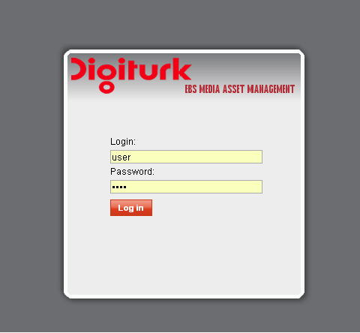

Figure 1.1

Menu:

When the user logs in the application the stats window is displayed. There are six main areas: (Figure 2.1):

EPG Data
In this section, it is possible to manage automatic-recording contents (Search, Edit, Remove, Publish …).

PVOD Data
In this section, it is possible to manage VOD contents (Search, Edit, Remove …).

Scheduling
In this section, it is possible to manage & track daily-published EPG/VOD events (Monitor status, Depublish, Extends life …).

Manual Recommendations

In this section, it is possible to manage Recommendations (Create, Remove, Send to STBs …).

Channel Logos

In this section, it is possible to manage Channel logos.

Banners
In this section, it is possible to manage Banners.



Figure 2.1

Automatic-recording Management:

Search

The search process (Figure 3.1) for retrieving EPG records stored in EBS HeadEnd repository (after processing Epgs xml files coming from Lysis System), is based on 5 search filters namely :
- Time interval Start (From).
- Time interval End (To).
- Master Production ID (optional). – Id event equivalent to Fcode for Mediaset.
- Title (optional). – Title of event
- Channel - Service

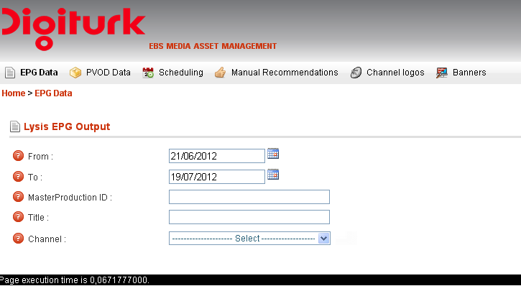

Figure 3.1

In order to perform search click on menu tab “EPG Data”, set search filters, and then click button “Search”. The list of EPG appears (Figure 3.2).

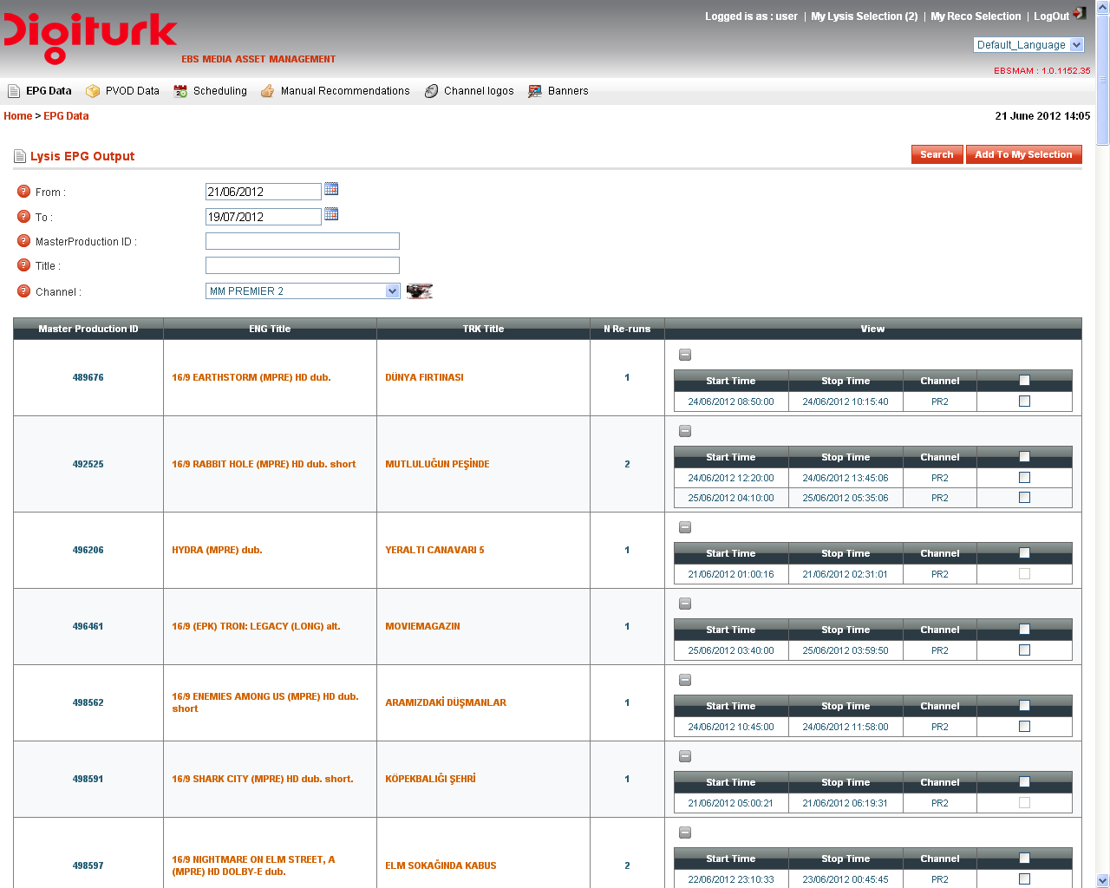

Figure 3.2

View EPG Details

Basic Info for a particular EPG event can be displayed by clicking either on English title (ENG Title ) or Turkish title (TRK Title) hyperlinks (Figure 3.2), user will redirect to another web form (Figure 3.2.1).

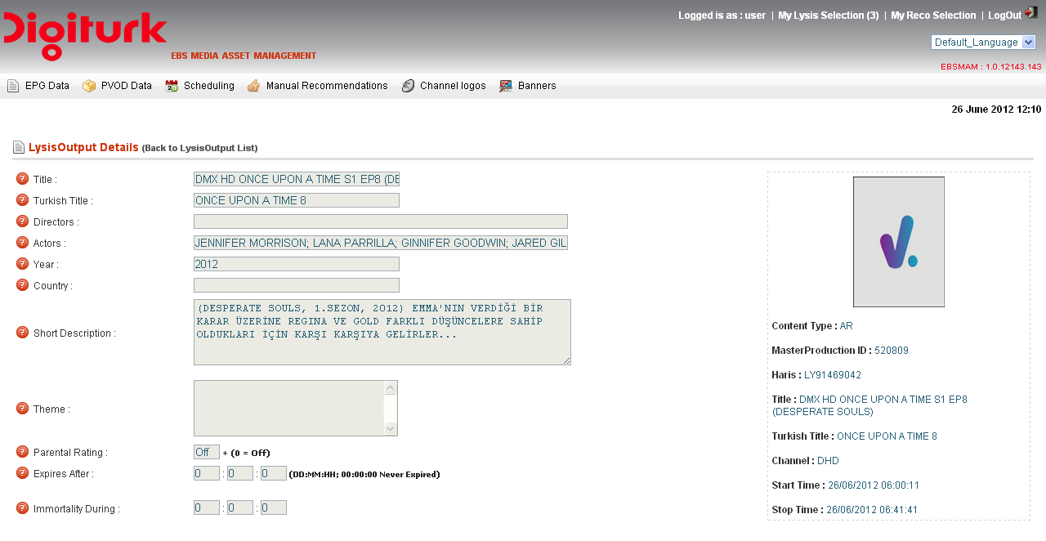

Figure 3.2.1

Prepare Custom User EPG collection to be Recorded

EBS Asset manager allows users to create their own customized EPG events selection (this is a persistent collection; it remains into the system even the user logout from the EBSMAM web application).

User EPG collection are feed only from EPG got from processing Lysis system xml files output, from this collection user can publish those which will be recorded by STB – refer to section 3.5.

Add EPG event(s) to User Collection
In order to create an EPG events collection, perform the search first (refer to section 3.1), then check the checkbox associated to each EPG event (last column of the grid view), and then click to “Add To My Selection” button (Figure 3.3.1).

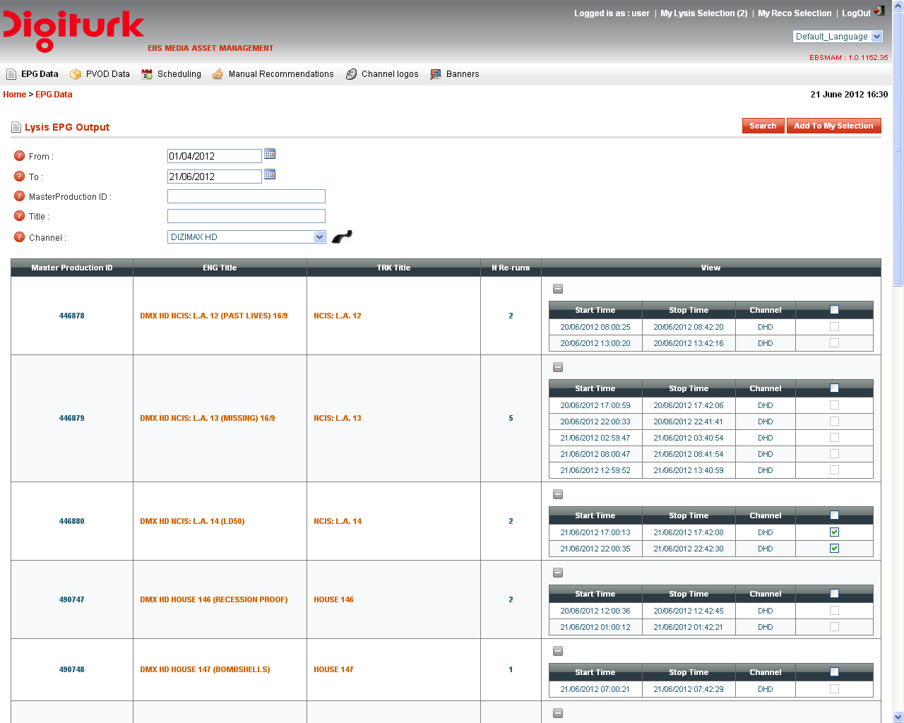

Figure 3.3.1

Note:
- XX minutes before EPG event estimated start date time, the associated EPG event checkbox is disabled,
the user cannot check it, and then cannot added to its own EPG collection (Figure 3.3.2).

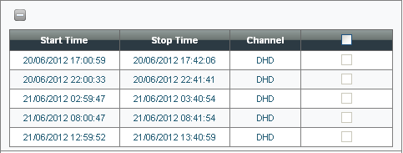
Figure 3.3.2

- This parameter can be set by using EBS Administration & configuration web application (Figure 3.3.3).

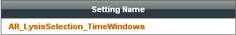

Figure 3.3.3

The click to “Add To My Selection” button (Figure 3.3.4) will redirect user to another web form which display the list of EPG events already selected by him.

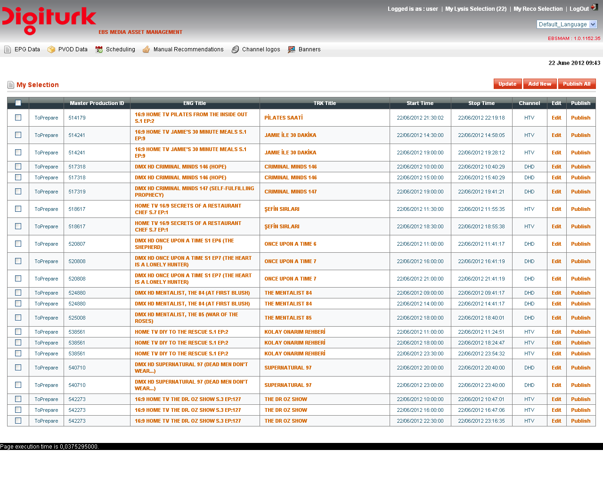
Figure 3.3.4

Remove EPG event(s) from User Collection

EBSMAM web application offers to users the ability to remove unwanted EPG event(s) from its selection, in order to do this the user can either:

- Clear its EPG Event(s) selection, by checking the top checkbox in the first columns of the grid view
- (Figure 3.3.4).

- Remove a unique or a set of EPG event, by checking their associated check box (first column of the grid view) - (Figure 3.3.4).

To apply this change user have to click the button “Update”, then the grid view is reloaded with updated information.

Edit EPG Event

An EPG event cannot be published before been edited, due to missing mandatory information namely:
- Theme
- Cover
In order to edit a particular EPG event, click its associated “Edit” hyperlink (Figure 3.3.4), the user will be redirect to another web form (Figure 3.4.1), by clicking the “Checkout” button the EPG event metadata are unlocked and user can set or update any one of them (Figure 3.3.2).

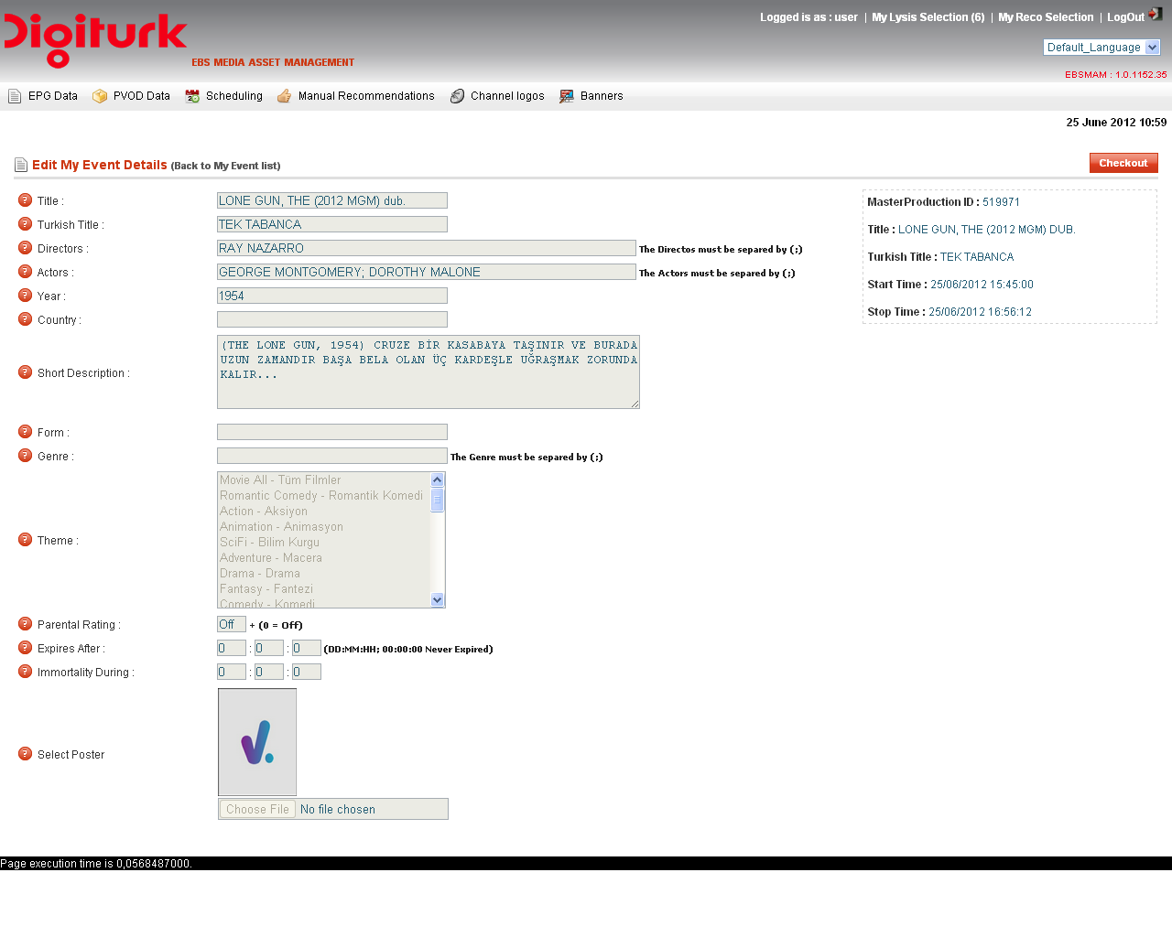Figure 3.4.1

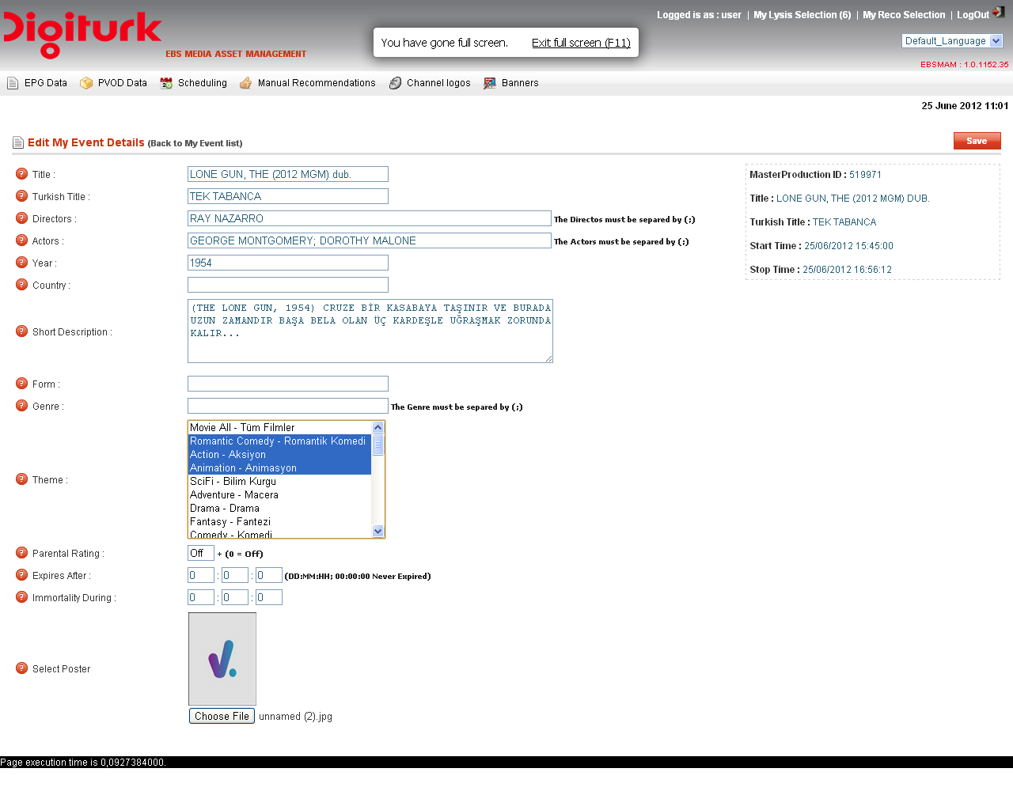
Figure 3.4.2

To apply this change user have to click the button “Save”, a confirmation message “Data Updated Successfully” will appear on the top of the web page (Figure 3.4.3).

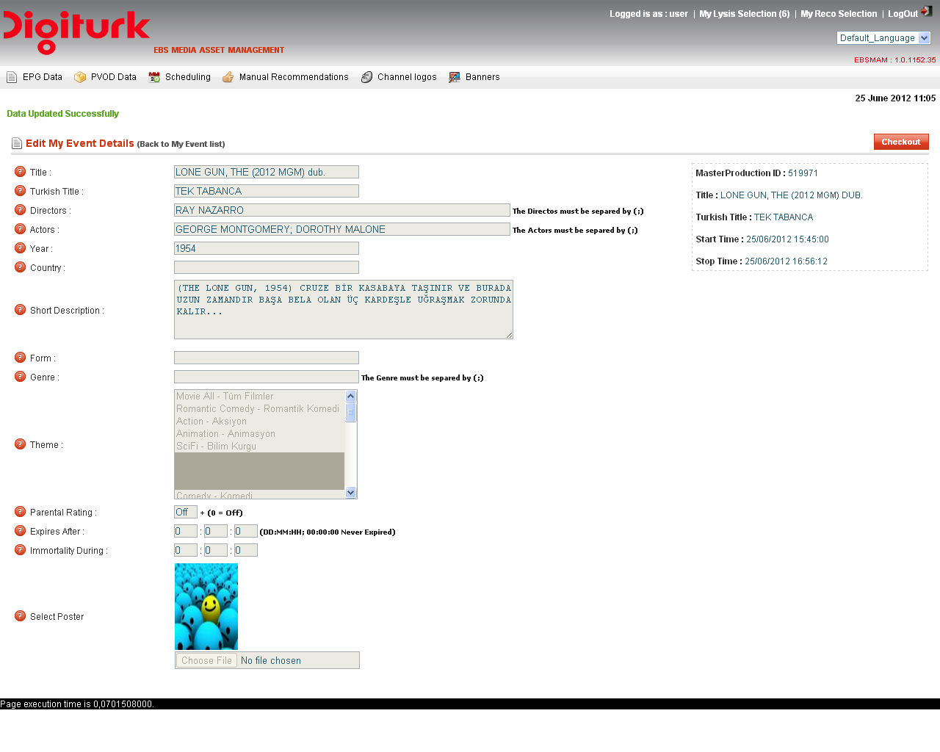

Figure 3.4.3

Note:
- XX minutes is the duration allowed for editing an EPG, after this time is elapsed an error message “Editing
Time Out” appear and the changes are discarded (Figure 3.4.4).
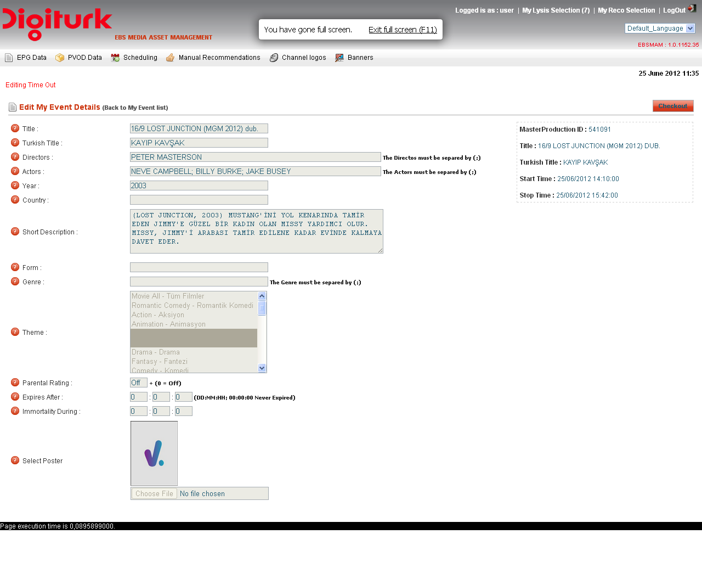
Figure 3.4.4

- This parameter can be set by using EBS Administration & configuration web application (Figure 3.4.5).

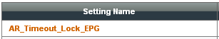

Figure 3.4.5

Publish EPG Event

From user EPG event(s) collection (Figure 3.4.4), it is possible to publish a particular or a set of EPG Event.

- Click “Publish All” button to publish all EPG event(s) in user selection.

- Click associated EPG event “Publish” hyper link (last columns in grid view) - Figure 3.4.4.

Note:
- XX minutes before EPG event estimated start date time, publish action is not allowed, and a warning
message is shown just below grid view (Figure 3.5.1).

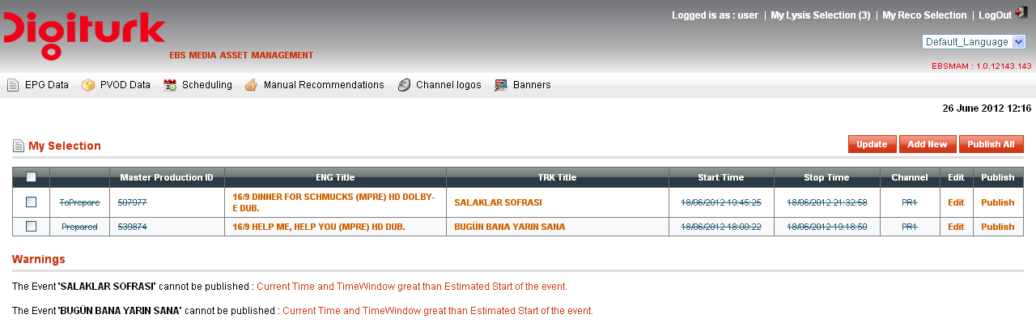

Figure 3.5.1

- This parameter can be set by using EBS Administration & configuration web application (Figure 3.5.2).

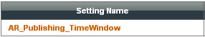

Figure 3.5.2

Manage Publish EPG Event

Unlocked published EPG event(s) can be either:

- Edited (change Metadata, re-associate cover …) - refer to section 3.4.

- Removed from schedule grid.

- Extend their life inside STB HDD.

To perfom the tasks below, click sub-menu Automatic-recording (Figure 3.6.1), the user will be redirect to another web form contains the automatic-recording schedule grid (Figure 3.6.2).

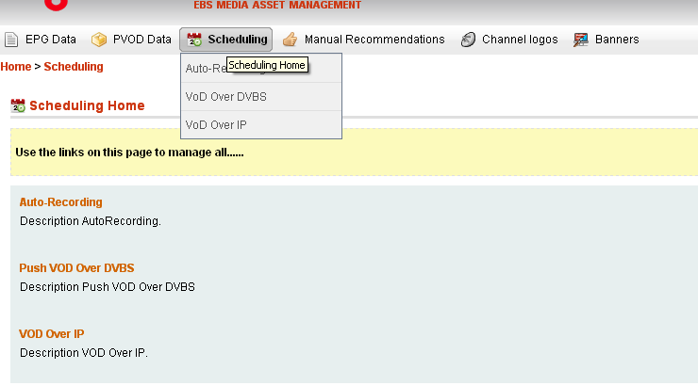

Figure 3.6.1

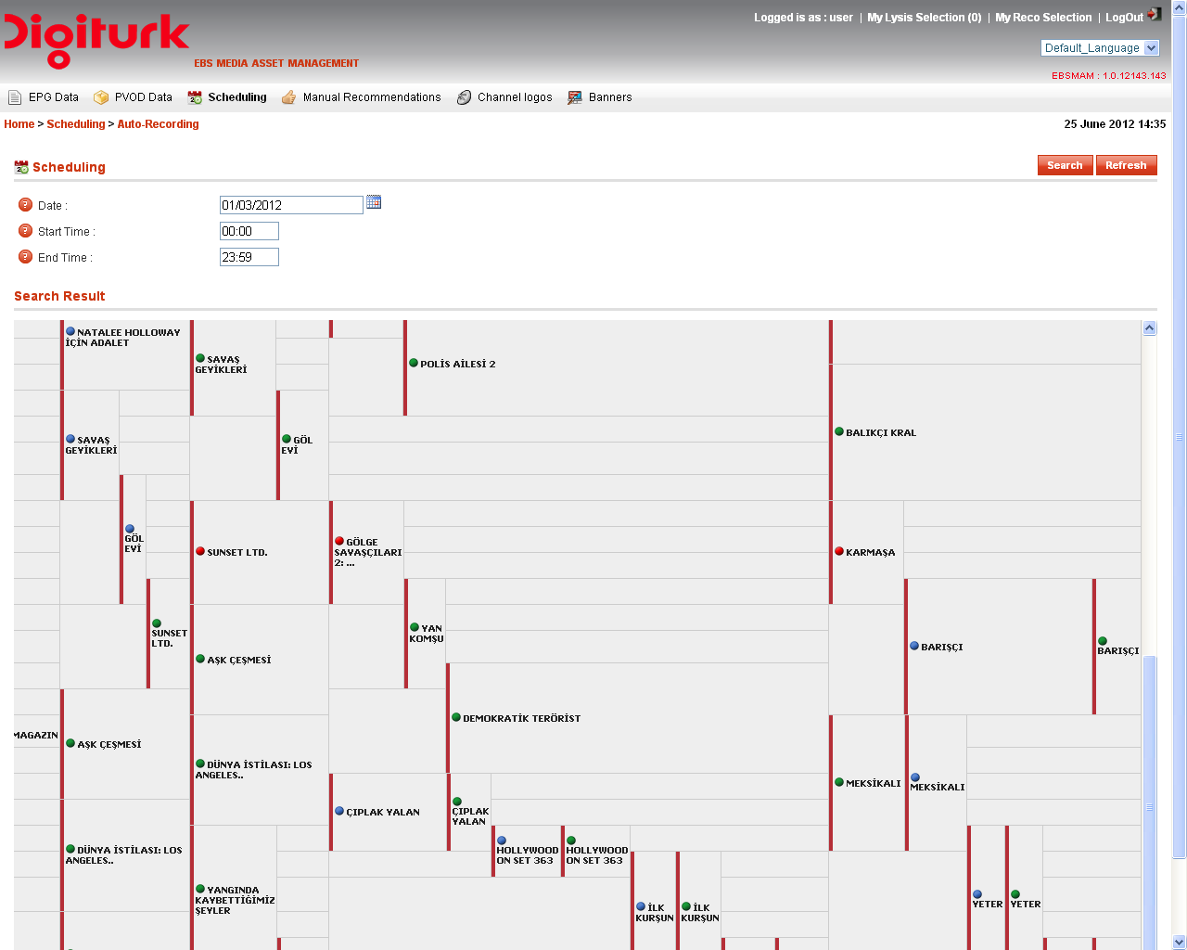

Figure 3.6.2

Within the schedule grid, click EPG title hyper link, this will redirect the user to another web form – refer to section 3.4 for how edit EPG event metadata.

Edit EPG event
Refer to section 3.4

Depublish EPG event
Refer to section 3.4

Extends EPG event life
Refer to section 3.4

To extend EPG event life, user has to set new values for the following metadata:
Expires After:
Positive integer number specifying the amount of time (in minutes) after which the content will expire. If zero, infinity is used.

Immortal During:
Positive integer number specifying the amount of time (in minutes) during which the content will be immortal. This value cannot be greater than ‘ExpiresAfter’.

Once user click “Save” button, the extension life command is sent to the STBs, and the message “Data Updated Successfully” appear on the top of the web form (Refer to section 3.4).

Note:
- EPG Extension life command is sent only for those who are already been recorded.
- For future EPGs, new values of “Expires After” and “Immortal During” will erase the old ones.
- XX minutes before EPG event estimated start date time, the associated EPG event is locked and no action
can be made on it (Figure 3.6.3).

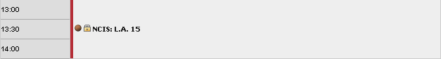
Figure 3.6.3

- This parameter can be set by using EBS Administration & configuration web application (Figure 3.6.4).

Figure 3.6.4

Datacasting Management:

Search

The search process (Figure 4.1.1) for retrieving Datacasting records stored in EBS HeadEnd database (after processing .tar packages), is based on 5 search filters namely :
- Time interval Start (From).
- Time interval End (To).
- Business Models (optional).
- Package Asset ID (optional).
- Video Asset ID (optional).

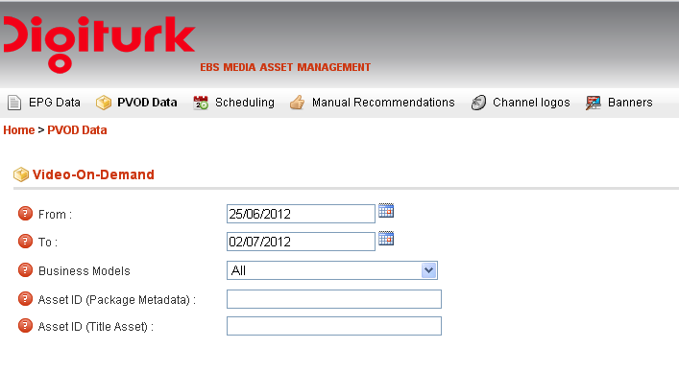
Figure 4.1.1

In order to perform search click on menu tab “PVOD Data” – refer to section 2-, set search filters, and then click button “Search”. The list of VOD contents appears (Figure 4.1.2).

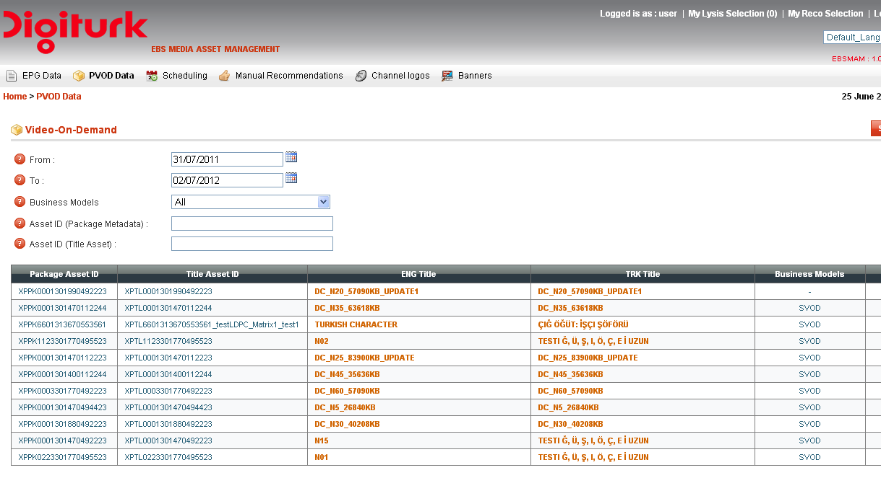

Figure 4.1.2

Edit VOD content
VOD content metadata can be displayed by clicking either on English title (ENG Title ) column text or Turkish title (TRK Title) column text hyperlinks (Figure 22), user will redirect to another web form (Figure 4.2.1).

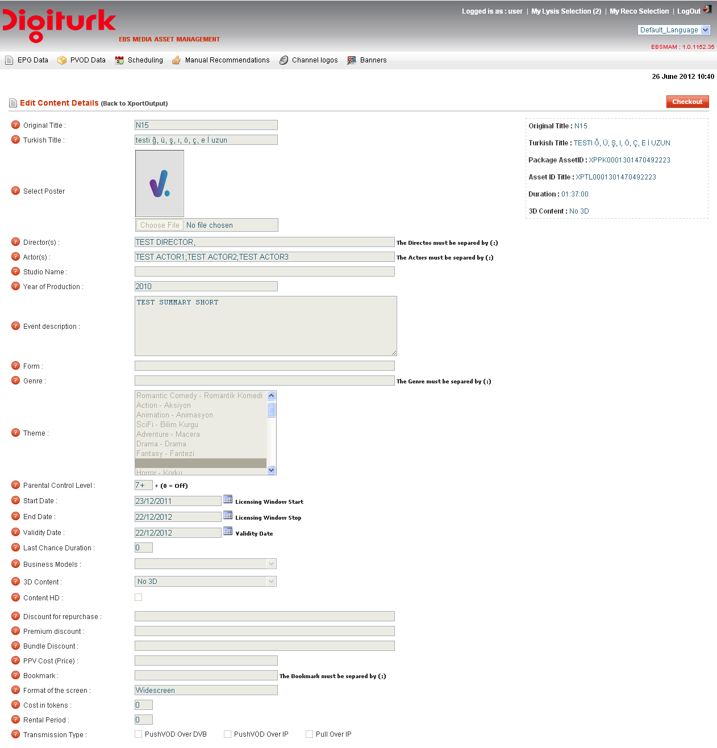

Figure 4.2.1

By clicking the “Checkout” button the VOD content metadata are unlocked and user can set or update any one of them (Figure 4.2.2).
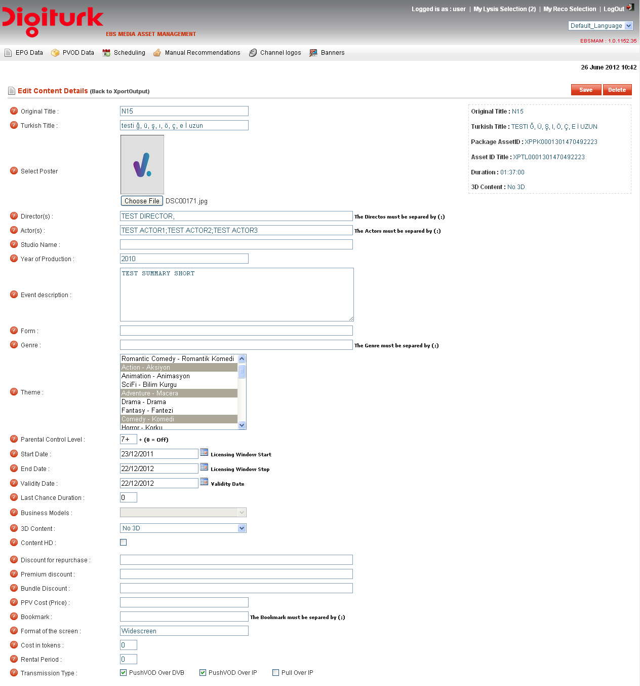

Figure 4.2.2

To apply this change user have to click the button “Save”, a confirmation message “Data Updated Successfully” will appear on the top of the web page (Figure 4.2.3).

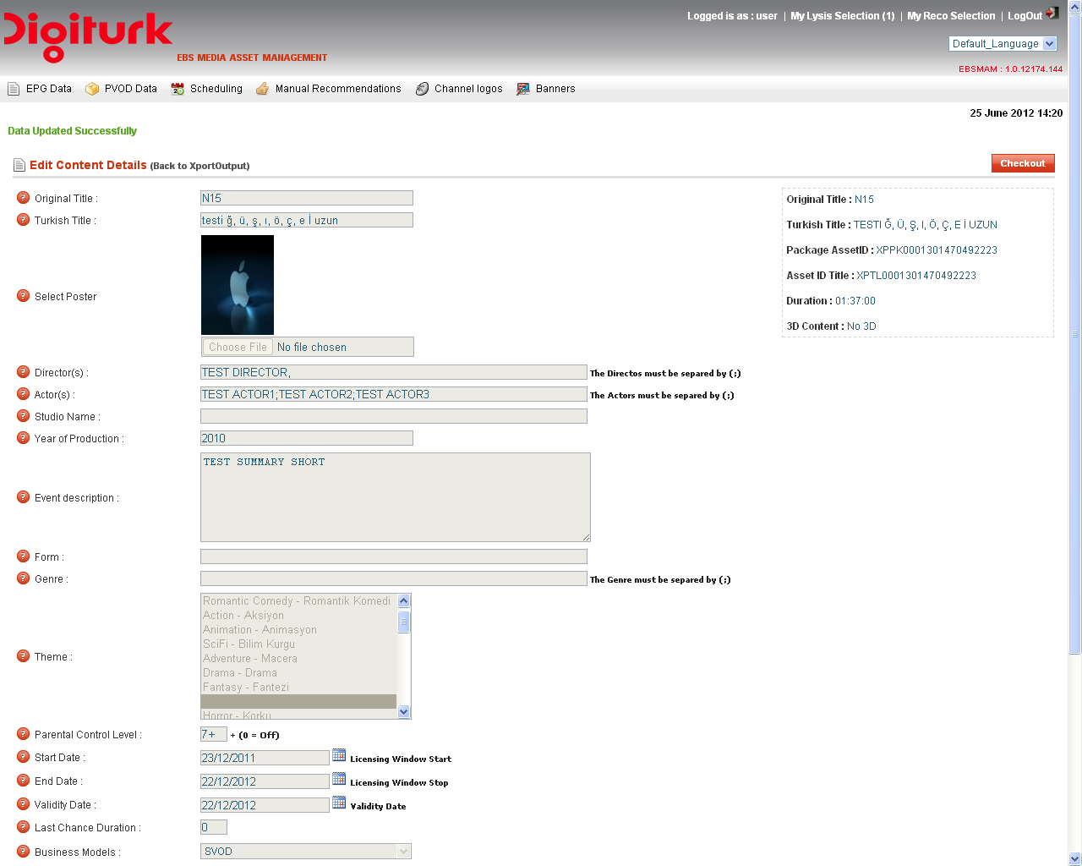

Figure 4.2.3

Note:
- In spite of checking “Transmission Type” (Figure 4.2.4) is not mandatory during saving VOD metadata change, it is suitable to set it, this enable content to be selected during publish process.

Figure 4.2.4

Publish VOD content

In order to publish VOD content over DVBS, click sub-menu “Vod Over DVBS” (Figure 4.3.1), the user will be redirect to another web form contains the VOD contents schedule grid (Figure 4.3.2).

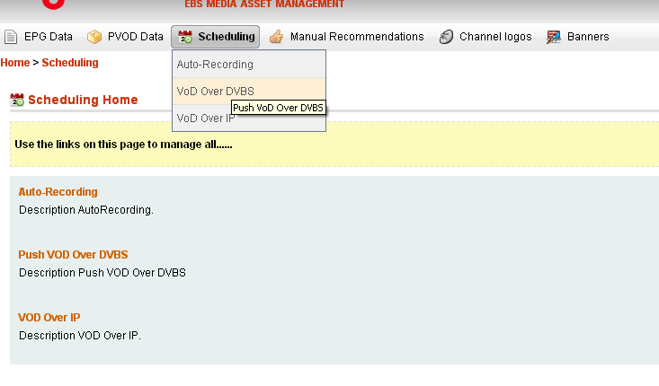
Figure 4.3.1

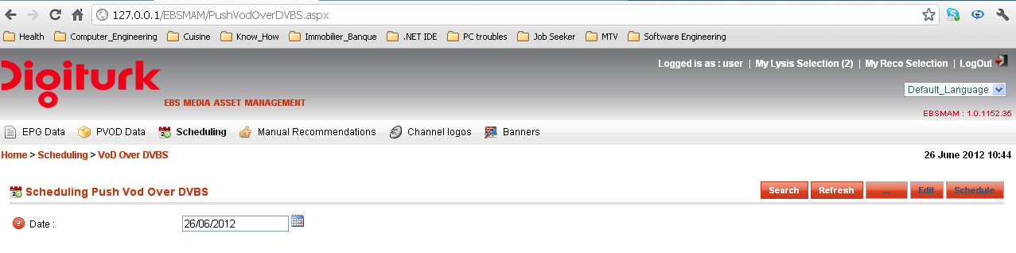

Figure 4.3.2

This web form allows user to perform date-based search, just select the date and then click “Search”, the system display the VOD schedule grid (Figure 4.3.3).

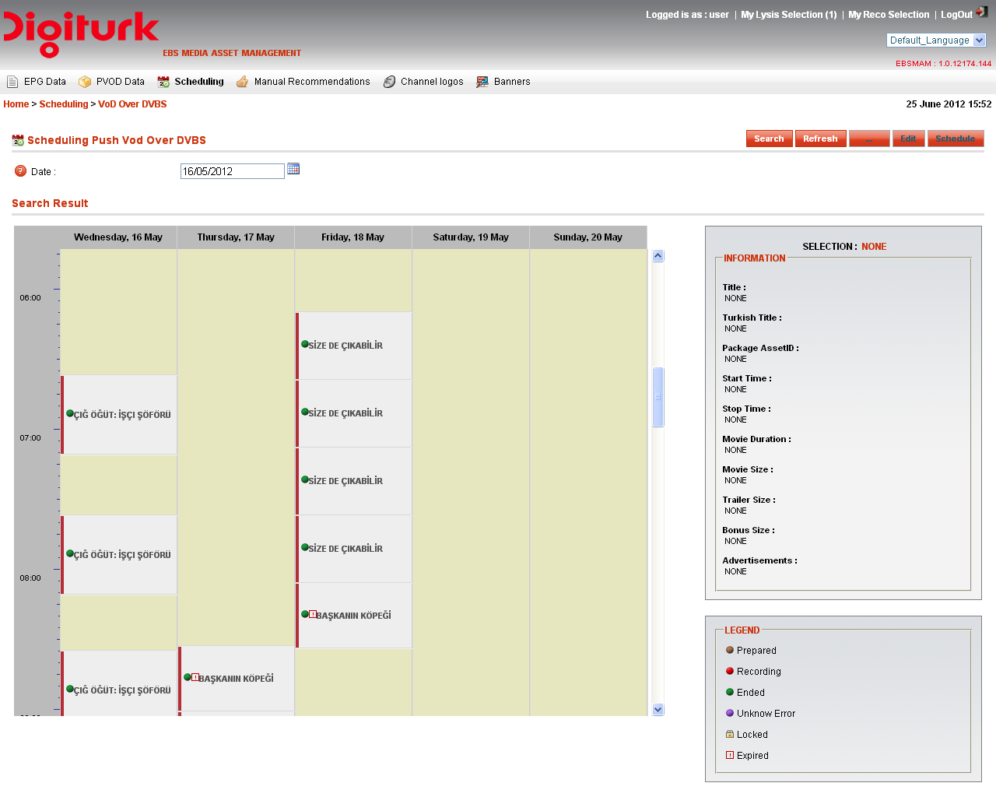
Figure 4.3.3
Select free zone (gray color) within the schedule grille, and then click browse button, this will redirect the user to another web form (Figure 4.3.4).

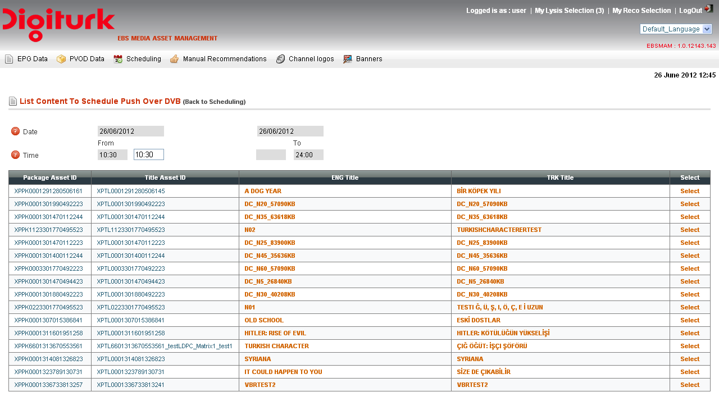
Figure 4.3.4

Within this web form user can:
- Select VOD content to be published by clicking “Select” button from last columns in the grid view.
- Adjust Start time of sending VOD content process.
By clicking “Select” the user will return to main VOD schedule web form, and the “Schedule” button becomes enabled.
One the user click “Schedule” button, a confirmation message “The Content Is Successufly Published.” is displayed on the top of the web form (Figure 4.3.5), the VOD content is now ready to be processed for sending.

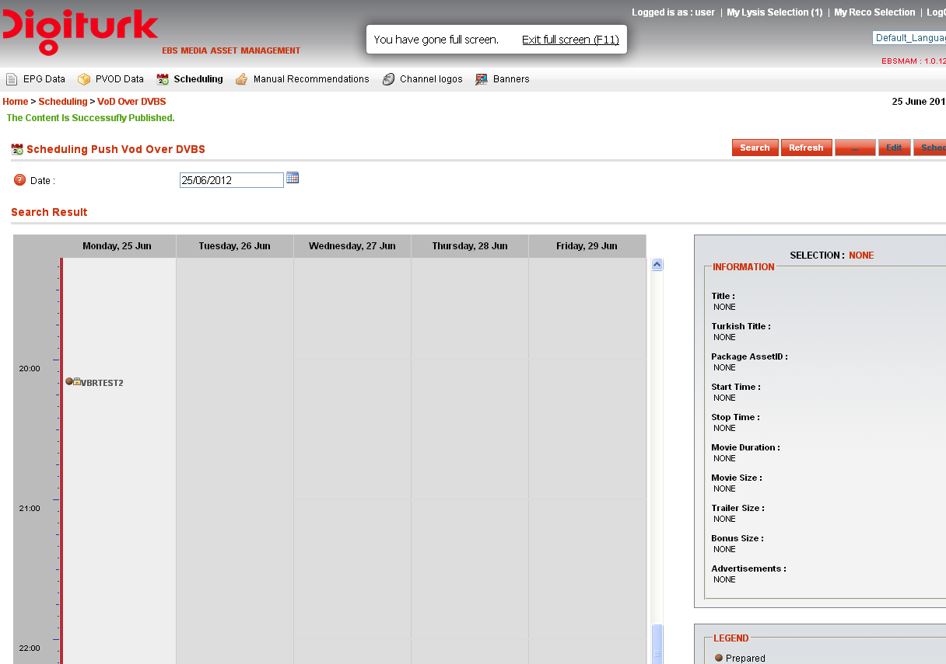

Figure 4.3.5
VOD content status can have one the following values (Figure 4.3.6):
- Prepared.
- Recording
- Ended
- Unknown Error
- Locked
- Expired

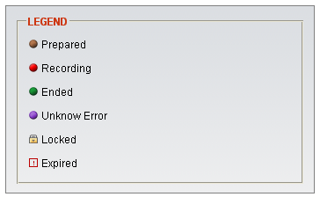

Figure 4.3.6

Manage published VOD content

Unlocked published VOD content(s) can be either:

- Edited (Change Metadata, re-associate cover …).

- Depublisehd from the schedule grid - refer to section 4.2.

- Extend their life inside STB HDD.

Edit VOD content
Refer to section 4.2

Depublish VOD content
Refer to section 4.2

Extends VOD content life
Refer to section 4.2
To extend EPG event life, user has to set new values for the following metadata:
End Date:
Last date on which the product can be viewed, expiration date.

Validity Date:
It defines until when user can purchase an event. It can be equal to expiration date (in this case user can purchase an event until event expires, meaning user may purchase an event even if event expires before viewing duration

Once user click “Save” button, the extension life command is sent to the STBs, and the message “Data Updated Successfully” appear on the top of the web form (Refer to section 4.2).

Note:
- VOD Extension life command is sent only for those who are already been recorded.
- For future VOD content(s), new values of “Expires After” and “Immortal During” will erase the old ones.
- XX minutes before VOD content estimated start date time, the VOD content is locked and no action
can be made on it (Figure 4.4.1).

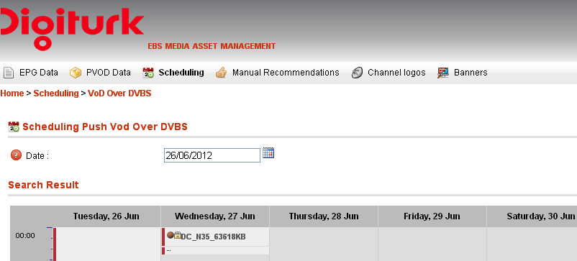
Figure 4.4.1

- This parameter can be set by using EBS Administration & configuration web application (Figure 4.4.2).

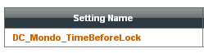

Figure 4.4.2

Broadcasting Manual Recommendations:

Search
This section allows user to prepare a selection of events (AR, VOD, Live event) to be recommended for the end user, and then send it to the STBs.

First of all the users have to prepare event selection to be sent, this can be done by clicking “Events Selection” from Manual Recommendations menu (Figure 5.1.1).

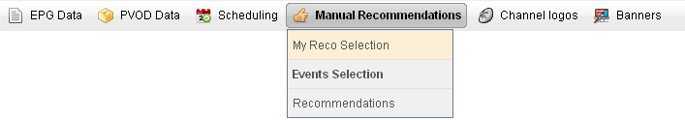

Figure 5.1.1

By clicking “Events Selection”, the user is redirect to another web form, which allows him to search for events (Figure 5.1.2):

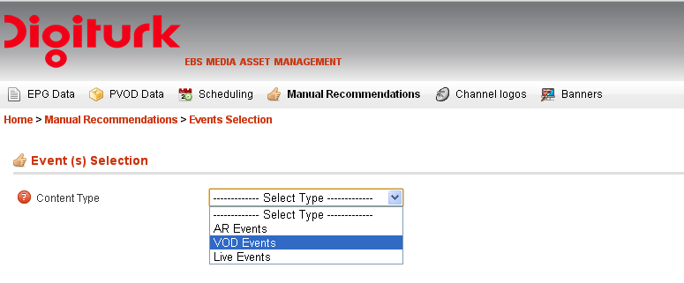
Figure 5.1.2

The search process is based on several filters according to Event Type namely:

- AR Events (Already recorded EPG event in STB HDD).

- VOD Events (Already recorded EPG event in STB HDD).

- Live Events (Future EPG events).

AR Events / Live Events

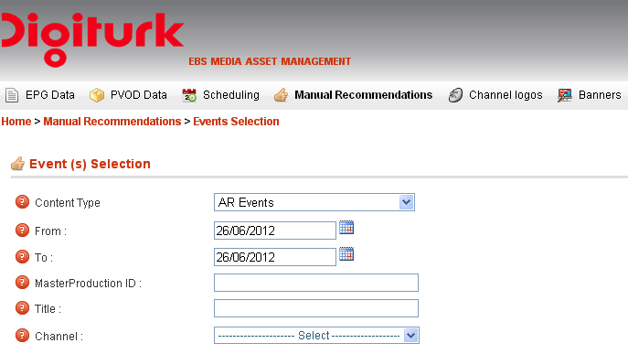

Figure 5.1.3
- Time interval Start (From).
- Time interval End (To).
- Master Production ID (optional).
- Title (optional).
- Channel.
By clicking search the List of AR event (Figure 5.1.4) or Live AR event, appear (Figure 5.1.5)
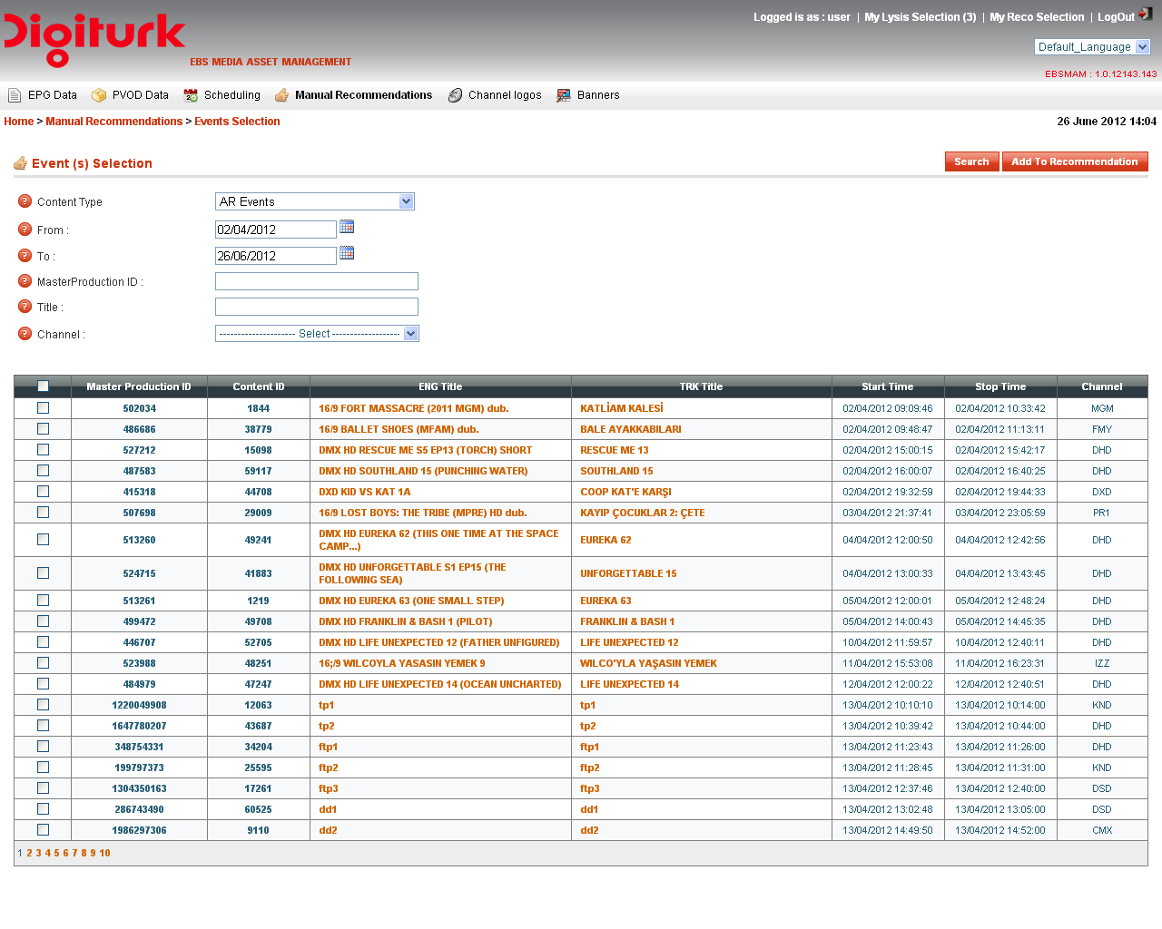
Figure 5.1.4

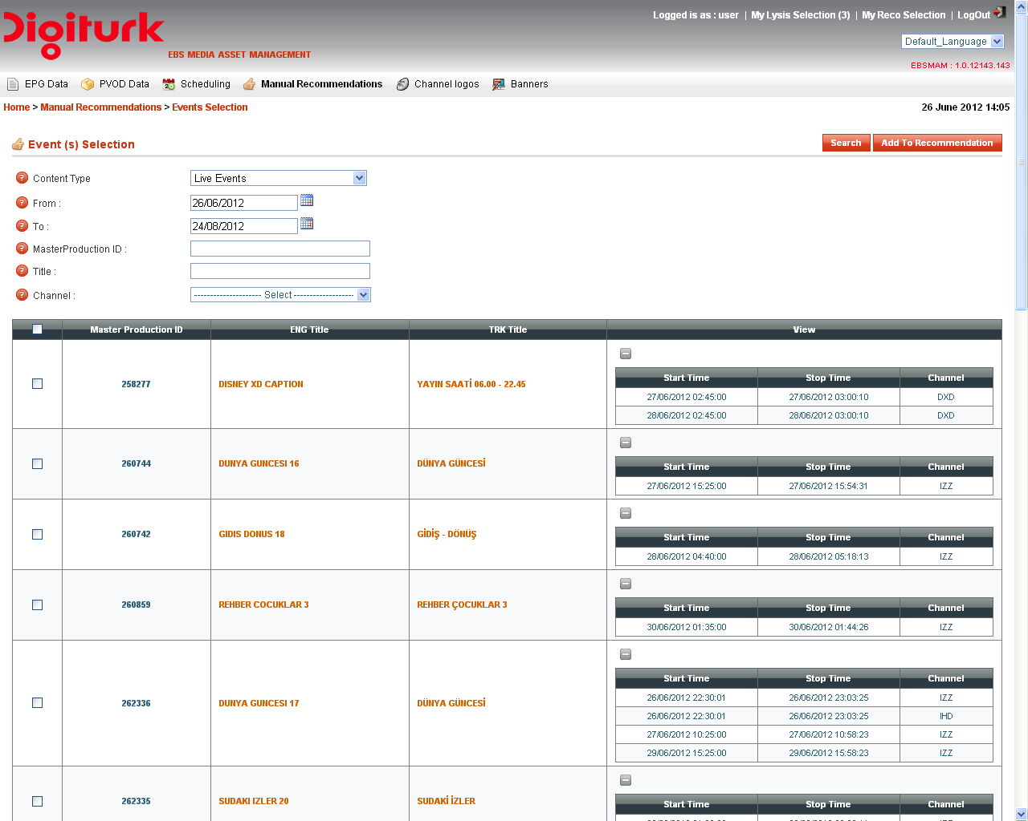

Figure 5.1.5

VOD Events
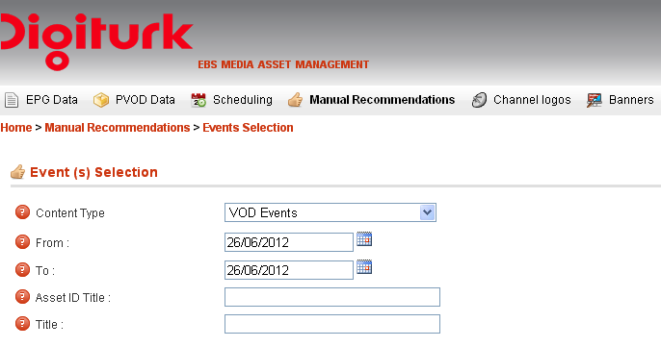
Figure 5.1.6
- Time interval Start (From).
- Time interval End (To).
- Asset ID Title(optional).
- Title (optional).

By clicking search the List of VOD event, appear (Figure 5.1.7).
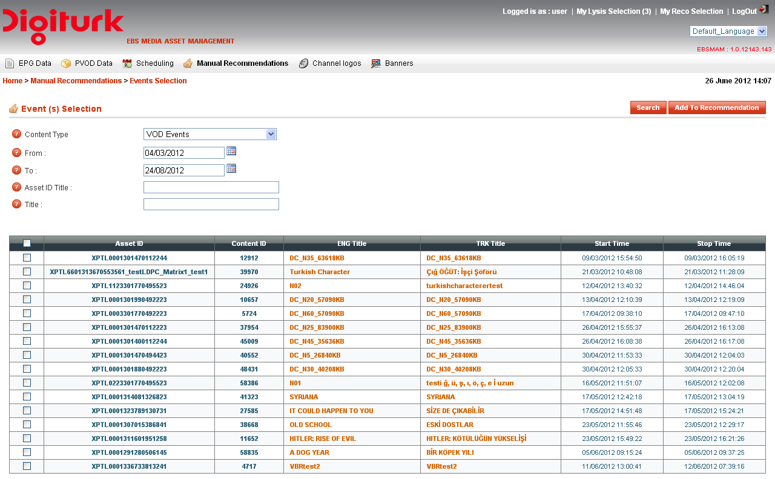
Figure 5.1.7

Create Custom Recommendation EPG events collection
Check the associated event checkboxes in the first columns (Figure 5.1.4, 5.1.5, 5.1.7), then by clicking to the “Add To Recommendation” the event selection is saved temporary to EBS HE system, and the user is redirect to another web form to set recommendation start and stop date and time (Figure 5.2.1).

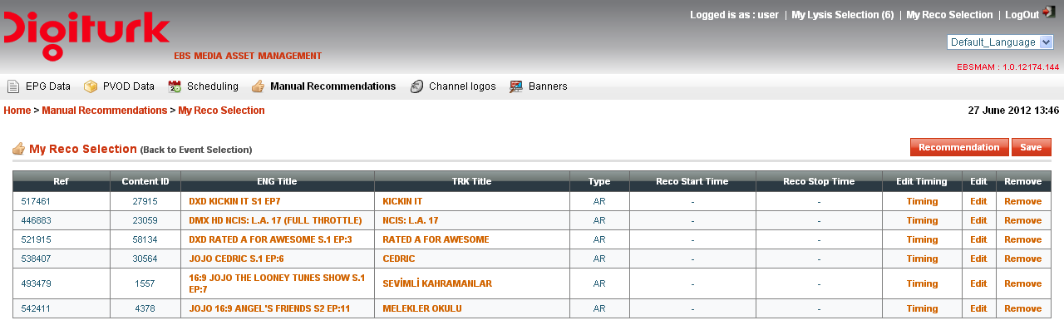
Figure 5.2.1
Note:
- Keep in mind that this VOD/EPG (AR, Live EPG) event collection is volatile, means that If the user doesn’t continue the whole process of recommendation, once he logs out from the EBSMAM web application the selection is anymore available
- Live event(s) need to be editing to complete missing metadata (Theme) and to associate cover – refer to section 3.4.

By clicking “Timing” hyperlink, the user is redirect to another web form to set appropriate start and stop date and time of this recommendation selection (Figure 5.2.3).
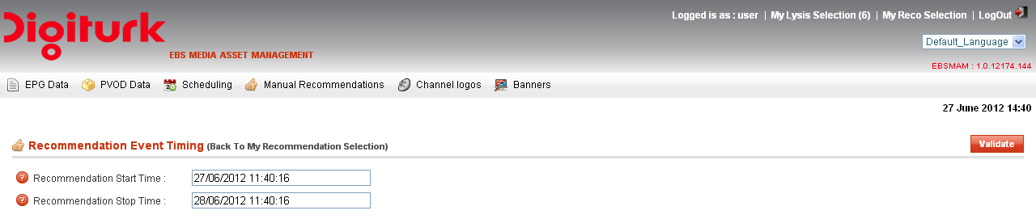
Figure 5.2.3

Note:
- Date Time format: dd/MM/yyy HH:mm:ss

By clicking, the “Save” button, the recommendation selection is saved into EBS HE system Database and locked (cannot be edited to remove or add new events)

At this stage, only two options are offered to the user namely (Figure 5.2.4):
Send : by clicking the “Send” hyperlink, the recommendation selection is sent to the STBs.
Delete: the recommendation selection is removed from EBS HE system.

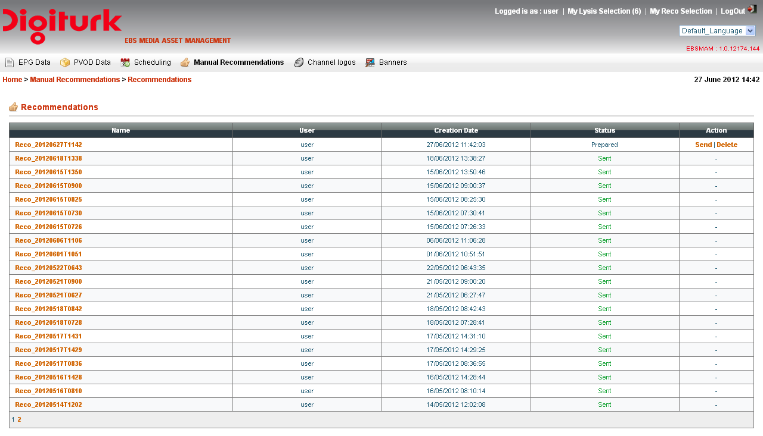
Figure 5.2.4

Broadcasting Banners:
This is achieved by preparing a compressed zip file, which contains banners files, and sends it to the STBs via the following EBS MAM web form (Figure 6.1):
BTW : for more details about Banners refer to specification “ebs extensions - reco + logos + ad banners + search + md export + castup v7.pdf”.
Figure 6.1
N.B: it’s highly important to respect the zip file name pattern ad_banners_yyyymmddThhmm.zip

Broadcasting Channels Logo
The broadcast of channels logo can be performed in two ways:
- Using EBSMAM for selecting logos to be sent from the list of channels already saved into EBS HE (trough
EBS admin & config). (Use red “Send” button)

- Prepare you own customized zip file and send it. (Use black “Send” button).

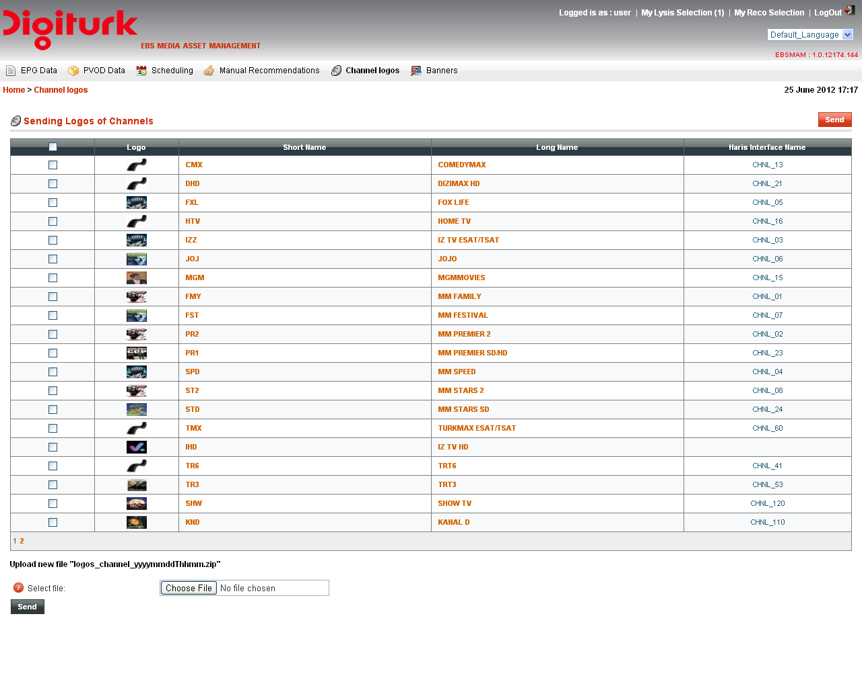
PS: for more details about creation of Logo channel zip file (option 2) refer to HeadEnd specification document
“ebs extensions - reco + logos + ad banners + search + md export + castup v7.pdf”.

Broadcasting Search Index File:
This is ensured by another EBS HeadEnd component and it is a widely automatic tasks.
PS: refer to HeadEnd specification document
“ebs extensions - reco + logos + ad banners + search + md export + castup v7.pdf”.

DigiTurk Site Guide
In this section, the different HeadEnd environments are listed. The IP addresses for each of the machines are also shown next to the machines.
The certification and production systems are available only from within the DigiTurk network or over a secure VPN connection from outside the DigiTurk network.

Production Environment Setup
In the production environment, the servers are as shown in the figure below:
EBS AR simulator (To simulate Harris Triggers)
- (Main : 178.28.28.23, BCK : 178.28.28.33)

EBS Xport Importer
EBS Scheduler
Encapsulator (DC) PID 86
- (Main : 178.28.28.22, BCK : 178.28.28.32)

EBS Configuration & Administration
EBSMAM (EBS Media Asset Management
EBSECW
EBS Lysis Importer
EBSWebSimulator
EBSEventListener
- NLB : 178.28.28.20
- (Main : 178.28.28.21, BCK : 178.28.28.31)

EBS Catalog Information
(EBSCIW)
Encapsulator (AR) PID 85
- (Main : 178.28.28.24, BCK : 178.28.28.34)

Certification Environment Setup
The certification environment is as shown in the figure below:
EBS AR simulator (To simulate Harris Triggers)

- 178.28.28.13
EBS Xport Importer
EBS Scheduler
Encapsulator (AR) PID 85
- 178.28.28.12
Encapsulator (DC) PID 86
- 178.28.28.14
EBS Configuration & Administration
EBSMAM (EBS Media Asset Management)
EBSECW
EBS Lysis Importer
EBSWebSimulator
EBSEventListener
- 178.28.28.11
EBS Catalog Information (EBSCIW)
The certification system is a replica of the production system having identical configurations and distribution of components.

Brief Components Description

- EBS Configuration & Administration: Consist to manage user account with defined access & authorization, category management, automation system IP and port, FTP details and other parameters related to EBS modules.

- EBSMAM (EBS Media Asset Management): Is Media asset system consists to manage Autorecording (AR), Datacatsing (DC), metadata associated with AR and poster images associated with AR & DC.
In the EBS MAM each event is associated with its corresponding metadata such as (title of the event, abstract, actors, event lifetime…).

- EBSECW: API for Motive catalogue information that allows data to be created and consumed over HTTP using RESTful service.

- EBS Lysis Importer: Is an Electronic Programs Guide grabber. It offers an easy and effective way to parse an Lysis EPG xml file input (got from Lysis System) and convert the data to an internal format supported by EBS system, necessary input are the Lysis EPG xml files.

- EBS Web Simulator: Simulate the Lysis EPG entries for testing.

- EBS Event Listener: EBS Harris connector.

- EBS Catalog Information (EBSCIW): Service that provides list of the categories and their not expired scheduled contents (AR and DC).

- EBS Scheduler: To automate jobs such as to prepare the start and stop commands for the DC whenever necessary and the poster files, index files, to be data-casted to the box.

- EBS Xport Importer: It offers an easy and effective way to extract tar Xport package input (got from Xport System) and convert the data to an internal format supported by EBS system, necessary input is tar package file.

- EBS AR simulator : To simulate Harris Triggers.

- EBS DC Error correction: This module is responsible of preprocessing incoming transport stream files adding redundancy to them, DC files can be sent applying forward error correction mechanisms to it in order to maximize data integrity under transmission channels with losses. In particular, this module is implementing LDPC (Low Density Parity Check) Codes in a block basis in order to add the desired amount of redundancy matching the implementation requirements.

- Encapsulator (AR): This application actually converts the incoming AR metadata & triggers into TS format and transfers it to the mux over ASI. This application needs to be configured to output the TS stream at a bitrate that matches the bitrate at which the mux can accept the ASI connection.

- Encapsulator (DC): runs the same components as the encapsulator AR above with the difference that it encapsulates the content to be sent as Datacasting content and transmits it over ASI to the mux.

How to Configure Channels
In this section it is possible to manage information about Channel extracted from EPG Lysis XML file, administrator can do the following:
- Associate Logo to a giving Channel (to be sent later to the STB trough recommendation section in EBS MAM).
- Set Harris Interface Name or BUS (Mandatory if the operator consider to schedule event in this channel, this is the same value sent within Harris triggers).
- Edit Channel Metadata.
- Add / Remove a giving Channel.

N.B:
Add, remove and edit Channel Metadata namely:
- Channel Name (long name).
- iDTV3 Interface Name (short Name)
Are an extended options offered to theEBS Aadministrator, it’s strictly recommended to not use them unless it’s really needed, since those Metadata are accurate and come from real EPG Lysis automation system XML file output.

Lysis output channels :

Figure 11.1

Add new channel :
In order to add new Channel, click button from Configuration Channel main page (Figure 11.1), click this will redirect Administrator to another web form, fill the form, associate logo and click button (Figure 11.2), click this button will save data into repository and redirect the Administrator to (Figure 11.3)
Figure 11.2
Where the mandatory params are :

- Channel Name: Channel long name.
- iDTV3 Interface Name : Channel short name.
- Harris Interface name: Harris Bus.
- Lysis ID : Any Value between 0 & 65535
- Audio Type: Channel audio type, the possible values are Stereo, Dolby Digital & Dolby Digital Plus, and these values are used in the recommendation xml file.
- Is 3D Channel: Is 3D channel.
- File uploader : Used to upload logo channel into EBS repository.

Edit / Remove Channel

Figure 11.3
In order to remove an already stored Channel, click Channel’s associated button, from the channel list (Figure 11.1), this will redirect the administrator to new web form (Figure 11.3).
- Edit: Fill form with new required Metadata values and click .
- Remove click button.

How To Configure DVB-Triplet:
Menu: Configuration -> Channel -> Channel DVB-Triplet(s) Mapping.
In this section it is possible to manage information about channel DVB-Triplet, administrator can do the following:
- Add DVB-Triplet to a specific channel.
- Remove & Edit an existing DVB-Triplet for a specific channel.

Search List Channel DVB-Triplet :
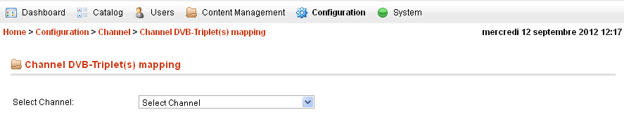
Figure 12.1
To get the DVB-Triplet linked to a channel, select the this channel from the Dropdowlist (Form 12.1) and the list of DVP-Tripler appears plus the button "Add New" Figure (12.2).
Figure 12.2

Add new DVB-Triplet :
In order to add new DVB-Triplet to a Channel, click button from Configuration DVB-Triplet(s) mapping main page (Figure 13.2), click this will redirect Administrator to another web form, fill the form, associate logo and click button (Figure 13.3), click this button will save data into repository and redirect the Administrator to (Figure 13.4)
Figure 12.3

Where the mandatory params are:

- Service ID.
- Original Network ID.
- Transport Stream ID.

Edit / Remove DVB-Triplet(s)

Figure 12.4

In order to remove an already stored DVB-Triplet, click DVB-Triplet’s associated button, from the DVB-Triplet list (Figure 12.2), this will redirect the administrator to new web form (Figure 12.4).
- Edit: Fill form with new required Metadata values and click .
- Remove click button.

How To Configure System Service Importer
Menu : Configuration -> System Service Importer
Figure 13.1
In this section it is possible to manage information about System Service Importer(s) , administrator can Edit only RemoteURL for (EBS Xport Importer & EBS Lysis Importer) Figure 13.2

Figure 13.2
In order to edit an already stored Service Importer, click Importer associated button, from the Service Importer list (Figure 13.1), this will redirect the administrator to new web form (Figure 13.2).
- Edit: Remote URL with new required value and click .

N.B:
Add, remove service importer need to be done by Motive Administrator.
The Parameters: Name, Importer Type, Importer Status, Published, IP Address need to be edited by Motive Administrator.

How to configure Catalog :
Menu : Catalog -> Categories
In this section, it is possible to manage information about catalog, administrator can do the following:
- Add new Category to the catalog.
- Edit / Remove a Category
- Send the Category XMl file to STB.

List of Categories:
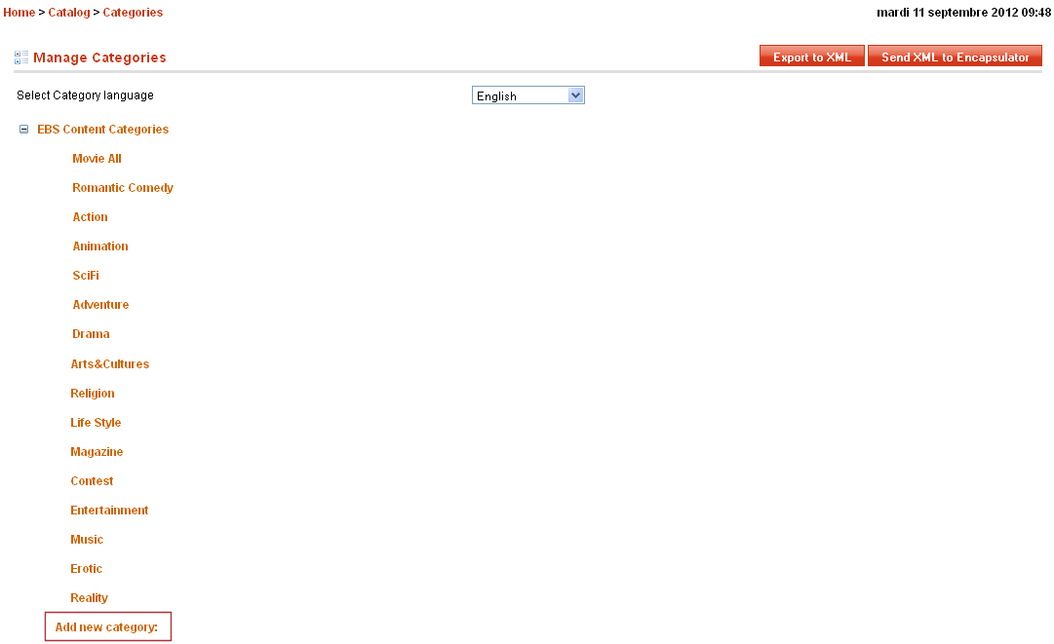
Figure 14.1

Add new Category :
In order to add new category, Click " " link from the Categories tree on categories main page (Figure 14.1). Click this will redirect Administrator to another web form, fill the form and click the button (Figure 14.2), click this button will save data into repository and redirect the administrator to Web Form (Figure 14.3).
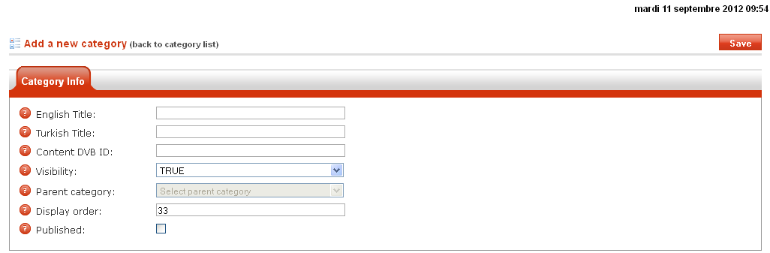
Figure 14.2
Where the mandatory params are:
- English Title: The Category name in English language.
- Turkish Title: The Category name in Turkish language.
- Content DVB ID:

Edit/Remove Category:
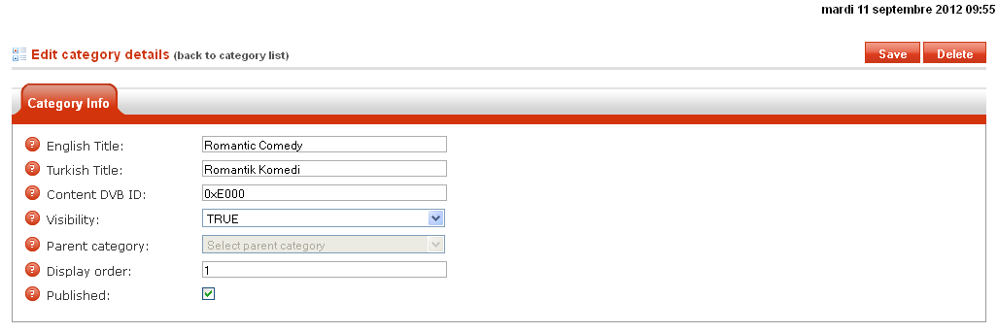
(Figure 14.3)
In order to remove an already stored Category click on category name, from the category list (Figure 14.1), this will redirect the administrator to new web form (Figure 14.3).
• Edit: Fill form with new required Metadata values and click .
• Remove click button.

EBS Parameters.

Global Settings (Easy Configuration):
Menu : Configuration -> Global Settings:
TimeInterval: this parameter can be configured by the administrator by marking the time when the operator can have the possibility the publish a packages.
To configure this parameter you need to use the tab “Time Interval” Figure (16.1)
Figure 15.1
User Bitrate : To configure the user bitrate , the administrator have two possibility by using the tab ‘Bitrate” on Global setting (Figure 15.2) , or use the All Settings (Figure 15.3)
- Using Tab Bitrate:
Figure 15.2
The Administrator need to set the new value and Click the button .
- Using All Settings:
Menu: Configuration -> All Settings
Using the All setting possibility, the administrator need to search for the parameter “DC_User_Bitrate” , fill the search key word zone and click the button (Figure 15.3).
Figure 15.3
Figure 15.4
In order to Edit the parameter, click parameter’s associated button, from the list (Figure 15.3), this will redirect the administrator to new web form (Figure 15.4).
- Edit: Fill form with new value and click .
NB:
- Since the transmission time interval allowed for an Asset is calculated based on the Assert Media file size and the bitrate, it’s strictely mandatory to aligne DC user Bitrate value with Encapsulator PushVoD Video bitrate (Figure 15.5)
Figure 15.5

All Settings:
The administrator can manage the following list of parameters:
Param Name | Param Description | Default Value
AR_LysisSelection_TimeWindows | X min before Estimated start time, the Selection from EPG entries is not allowed. | 1
AR_Max_Allowed_Diff_Freq | Indicates the maximum AR number, allowed to be recorded in different transponders. | 2
AR_Max_Allowed_Same_Freq | Indicates the maximum AR number, allowed to be recorded in a same transponder. | 2
AR_Mondo_TimeBeforeLock | X min Before Estimated start time, the Published event is Locked, no edition is allowed. | 5
AR_Publishing_TimeWindow | Editing or deleting a published event is not allowed x min before Estimated start time. | 1
AR_Show_Long_Description | True : Long Description will be shown in EBSMAM details interface - By Default = False. | False
AR_Show_Short_Description | True : Short Description will be shown in EBSMAM details interface - By Default = True. | True
DC_IntervalPackage | Time Interval in seconds between the end time of first video file and the start of the next video file on the same package, applicable only when package contains Movie and Trailer or Bonus or both. | 300
DC_Mondo_TimeBeforeLock | Editing or deleting a Scheduled content is not allowed x min before Estimated start time of sending package. | 45
DC_Time_Frame | The content can be published only X min from Current Time. | 45
DC_User_Bitrate | Push Vod video bitrate. | 2900000
Enable_Cover_Check_Before_Publishing | Enabled the Cover Check Before publishing a AutoRecording Or DataCasting. | True
PageSize | Sets the number of records to display on a page. Default Value : 20 records | 20
SchedulerFullTime | When false , only range values occurring in the data source are shown. When true (the default value), a continuous time scale is displayed. | True
SchedulerTimeInterval | An integer value giving the number of minutes for the interval (default=30). | 30
Search_Index_LastCreatedXmlFile | The last created search index xml file. | EBS_Events_for_search_20120910T1207.xml
Search_Index_LastDateSendZipFile | Search index zip file last sent time | 2012-09-04 14:10:41
Search_Index_LastDateXmlFile | search index xml file last created time | 2012-09-10 12:07:50
Search_Index_LastGeneratedZipFile | The last generated search index zip file. | search_index_20120911T1522.zip
Using_Auto_Refresh_Timer | Set Using_Auto-Refresh_Timer parameter to true to activate the task of refreshing web pages when you are viewing the system warning, Who is Online?, while monitoring user(s) activities history, Bulletin Board -Test Wall EBS System Software(s) and so one. | True

Managing the following parameter list need to be done by one of Motive Administrator since these are used internally by the system.
Param Name | Param Description | Default Value
AR_Cover_Channel_Sending | The Channel of sending the Auto-recording covers. | 1
AR_Cover_Max_Tries_Sending | The maximum number of tries to send an auto-recording cover | 1
AR_Default_ActiveTimeAfterFirstAccess | specified the time that the content will be active after it has been watched for the first time | 0
AR_Default_AdInsertionTarget | The default target for the adv insertion elements. | ams
AR_Default_BroadcasterId | The default number of the broadcaster. | 513
AR_Default_CopyControl | indicates the copy control restriction to be applied for this content. | copy once
AR_Default_DisableAccess | number specifing the default accessibility of the auto-recording content. | False
AR_Default_DrmProtected | incdicates that the content is protected by a DRM system. | False
AR_Default_Expiration | Represnets the default expiration time for the auto-record contents. | 0
AR_Default_ExtendedInfoTarget | The default target for the extended info elements. | nslcore
AR_Default_Hidden | The number of queue, the auto-recording will live in. | False
AR_Default_Immortality | Represnets the default immortality time for the auto-record contents. | 0
AR_Default_LifeAfterActivation | number specifing the life of the content after it is activated for the first time. | 0
AR_Default_LifeAfterFirstAccess | umber specifing the life of the content after it is watched for the first time. | 0
AR_Default_MaxAccesses | specified the default number of times the user is allowed to access the content. | 10
AR_Default_MinActiveTimeAfterFirstAccess | specified the minimum time that the content will be active after it has been watched for the first time | 0
AR_Default_MinLifeAfterActivation | umber specifing the minimum life of the content after it is activated for the first time. | 0
AR_Default_MinLifeAfterFirstAccess | number specifing the minimum life of the content after it watched for the first time. | 0
AR_Default_Priority | number specifying the default priority of the auto-recording content. | 1
AR_Default_PublishAfter | The default time in nimutes to publish the auto-recording content. | 0
AR_Default_Queue | The number of queue, the auto-recording will live in. | 1
AR_Default_ServiceType | number that represents the type of the content 0 for content and 1 for adv. | dvb
AR_Default_SourcePath | The default recording source path for a AR content(tuner numner 0). | 0
AR_Default_SourceType | The default recording source type for a AR content(tuner). | tuner
AR_Default_Type | The default of the content(0 for auto-recoding). | 0
AR_Enable_Remove_Overlapping | Enable the delete of the overlapping auto-recording events if they are not locked. | True
AR_Harris_Trigger_DateTimeFormatProvider | Formatting operations convert the Harris UDP msg (VIDEO_INTIME / DURATION) to valid TimeSpan value. | HH:mm:ss:ff
BroadcasterID | Broadcaster ID (<32000) | 513
BroadcasterName | Broadcaster name (max. 24 chars) | DIGITURK
Cdx_Channel_Sending |  | 3
Cdx_Interval_Sending |  | 3
Cdx_Last_Sending_Time |  | 2012-08-15 07:59:59
Cdx_Max_Tries_Sending |  | 1
Cover_Max_Hight | Maximum cover hight. | 160
Cover_Max_Size | Maximum cover size. | 175
Cover_Max_Width | Maximum cover width. | 112
DCCommand_Sending_Interval |  | 5
DC_CheckTSFileAvailability |  | 120
DC_Cover_Channel_Sending |  | 2
DC_Cover_Max_Tries_Sending | The maximum number of tries to send an datacasting poster. | 1
DC_Mondo_TimeWindow |  | 1
DC_OverIP_DateLock | DateTime : Locking the Process of scheduling DC Over IP. | 2012-04-10 08:51:14
DC_OverIP_LockedBy | The operator Locking the Scheduling Over Ip Process. | -1
DC_OverIP_TimeOut_Lock | The Maximum time allowed to operator on Scheduling Over Ip Process. | 10
DC_Update_Existing_AssetID | Determines if the System allows the update of the information of an already ingestad AssetID content. | False
EBSMAM_IPAddressR |  | 172.28.28.28
EBSMAM_IPAddressS |  | 172.28.28.29
EBSMAM_PortReceive |  | 60200
EBSMAM_PortSend |  | 60200
Encryption_key |  | b472adcf-ec3b-4862-8ecd-cc4cbe24c660
Interval_Cover_Sending | The interval in minutes between the sent of each cover. | 5
Last_Cover_Sending | The sending time of the last sended cover. | 2012-09-11 11:50:15
LogoHeight | The Height for Logo Channel | 40
LogoWidth | The Width for Logo Channel | 40
Lysis_AddedPrograms |  | 156
Lysis_DeletedPrograms |  | 60
Lysis_GarbledChannels | Number of garbled channles during the last EBS Service Importer task (Parse last uploaded EPG Lysis xml file and fill EBS AR events database repository). | 173
Lysis_GarbledPrograms | Number of garbled programs during the last EBS Service Importer task (Parse last uploaded EPG Lysis xml file and fill EBS AR events database repository). | 3589
Lysis_LastCommandDateTime |  | 9/11/2012 8:34:27 AM
Lysis_LastXmlExportDateTime | Last EBS Service Importer task DateTime(Parse last uploaded EPG Lysis xml file and fill EBS AR events database repository). | 9/11/2012 11:25:11 AM
Lysis_LastXMLExportFile |  | LYS_00_120911_11080000.xml
Lysis_LastXmlExportResult |  | C:\EBSSetup\EBSImporter\EPG\\LYS_00_120911_11080000.xmlFile imported successfully;
Lysis_LocalXmlPath |  | \\127.0.0.1\LocalXMLEPG
Lysis_RemoteXmlURL |  | ftp://127.0.0.1/RemoteXMLEPG
Lysis_UpdatedPrograms |  | 29
Lysis_ValideChannels |  | 20
Lysis_ValidePrograms |  | 184
Reco_Logo_Ad_Channel_Sending | Channel of Encapsulator to Send the Reco_Logo_Ad | 7
Scheduler_Last_Code_Schedule | the last processed pâckege schedule | 4FD89589C062F76E8B0F6E5CFA8DB791
Scheduler_Last_Content_Guid | the last ^processed pâckege schedule | 7735e0dc-1d43-47cd-b0c5-72912b47970d
Scheduler_Last_Media_Type |  | 1
Scheduler_Last_Processing_System | the last ^processed pâckege schedule | 6
Scheduler_Last_Schedule_Status | the last ^processed pâckege schedule | 100
Xport_AddedPrograms | if not zero, Indicates the last processed Asset_id is a new content to be added in the system. | 1
Xport_LastAssetIdProcessed | The last Asset id sent by the Xport and processed by the EBS Connector stsrem. | XPTL0001336733813241
Xport_LastCommandDateTime | The time of the last Xport xml command recieved by the EBS Connector stsrem. | 8/22/2012 11:33:42 AM
Xport_UpdatedPrograms | if not zero, Indicates the last processed Asset_id is an already existing content to be updated into the system. | 0
AR_Enable_Updae_Event | Enable the update of the not locked auto-recording events. | True
Reco_Logo_Ad_Channel_Sending | Channel of Encapsulator to Send the Reco_Logo_Ad | 7
AR_Update_AutomationEvent | False Update all events (Including lysis events not published) when updating published event - By default false. | False
AR_Update_Locked_Published_Event | Allow to update All Locked Re-runes of the same event(default false). | True
AR_Update_Published | Allow to update All Re-runes of the same Event that already Published Events (default false). | True
Categorization_SubCategoryDepth | The maximum number of child categories for a parent category. | 0
DC_TimeInterval |  | 16777215
DC_Timeout_Lock | The Maximum time allowed to operator on package edition process. | 15
DC_TimeTable_DateLock |  | 2012-09-11 06:19:28
DC_TimeTable_LockedBy |  | -1
FTP_Banners_Folder | EBS Banners FTP server location. | /Banners/
FTP_ClearMedia_Folder | EBS Media FTP server location. | /ClearMedia/
FTP_Covers_Folder | EBS Covers FTP server location. | /Covers/
FTP_DTTLogos_Folder | EBS DTT logos FTP server location. | /DTTLogos/
FTP_IngestedMedia_Folder | EBS Ingested Media FTP server location. | /IngestedMedia/
FTP_InputAds_Folder | EBS Advertisment FTP server location. | /InputAds/
FTP_Password | The password associated with the FTP server credentials. | 1
FTP_Root_Folder | Specifies the root directory for FTP logins. | /Contents
FTP_SearchIndex_Folder | the path of the search index in the FTP server | /ZipSearchIndex/
FTP_User | The Login associated with the FTP server credentials. | Administrator
Redundancy_BlockSize | Redundancy block Size (buffer size) | 558
Redundancy_RedundancyRate | Redundancy rate (Min 0|Max 100 | 0
Redundancy_RepetitionSpace | Redundancy repetition space | 250
ShowExecutionTimer | True : show the page Execution Time, By Default = False. | false
Show_Error |  | False
AR_Publish_Time_Lock | Time on minutes that the Lysis system cannot updated or delete the Published records with the new ones. | 1

-End of Document-

